Directions to Seminar Room F
School of Humanities and Social Sciences
17 Mill Lane
Cambridge CB2 1RX

17 Mill Lane is behind the Pitt Building on Trumpington Street.

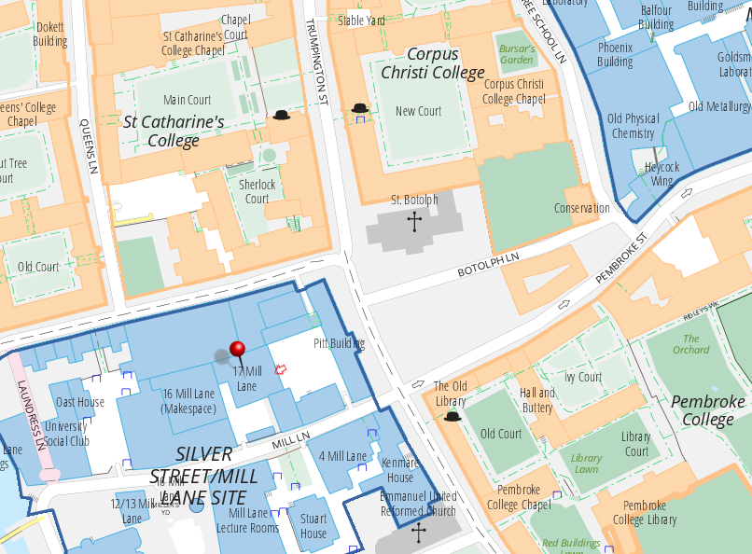

Enter the car park at 17 Mill Lane via the archway on either Silver Street or Mill Lane (circled in red). Go through the blue door (marked on the map with a red arrow), and take the stairs marked “Staircase B” to the second floor. Turn right and go down the corridor through two blue doors. Seminar Room F is then the second door on your left.

